Wherever you can, bring math into daily life:

Cook with your child – it involves weighing, measuring, ordering, estimating, adding, multiplying…. | 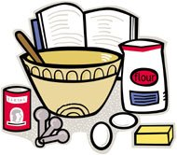
Discuss summer activities using the calendar (days, dates) and time.

Home projects – estimate, measure, multiply.

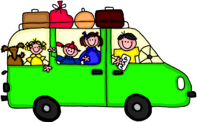 | Road trips
Talk about distance, speed, estimate length of the trip, gas usage, budgeting, evaluating various routes, license plate games (add/multiply numbers on the plates), etc.

Restaurants and shopping involves money, number identification, estimating, adding, subtracting, division….

BBQs or gatherings – estimate ratios of food/plate to people, needs, area of tables, cost of supplies, etc.

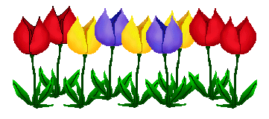 | Gardening –  involves measuring, counting, watering, area, division….

Links to Government of NB Math Parent Brochures, which contain book titles and links to internet resources:

Grade 5: http://www2.gnb.ca/content/dam/gnb/Departments/ed/pdf/K12/curric/Math/MathParentBrochure-Grade5.pdf

Grade 4: http://www2.gnb.ca/content/dam/gnb/Departments/ed/pdf/K12/curric/Math/MathParentBrochure-Grade4.pdf

Grade 3: http://www2.gnb.ca/content/dam/gnb/Departments/ed/pdf/K12/curric/Math/MathParentBrochure-Grade3.pdf

Brochure activity ideas from:
http://www.edu.gov.on.ca/eng/literacynumeracy/parentGuideNumEn.pdf

Links to other ideas for kids and teens:
http://www.edugains.ca/newsite/math/schoolleader/ideas_for_school_leaders.html

From your ASDW Numeracy Team

June 2017
Math at Home

Tips for Parents
to encourage summer retention of math concepts

This brochure contains some tips to help your child retain their math ability over the summer.

What is summer slide?
Over the summer, children get out of regular math practice, and tend to lose some of their ability and skill.
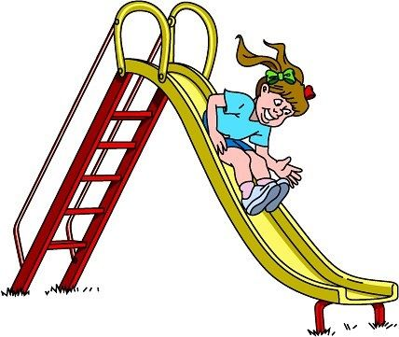

Math is everywhere:

“We are doubling this recipe. How much more of these ingredients will we need?”

“Do we have enough plates and utensils for all the guests coming?”

“We are fertilizing the lawn. This bag covers 3 square meters. How many bags will we need?”

“This store is selling the game you want for 20% off of $27.00. That store has it for $19.99. Where should we shop?”
Number Strand Activities
- Guess my number – 20 questions (Is it odd? Even? A whole number? A decimal? Divisible by 3? One digit?)
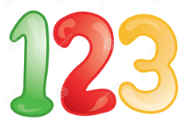

- Use skip counting to count objects or money. Count them by 2s, 5s, 10s or 25s.

- Do we have enough pillows/chairs/etc. for our house guests? Go count them.

- Card games – Play cribbage (counts to make 15); Number Shuffle Adding (each player draws two cards and adds them together, player with the highest number gets all the cards, player with most cards wins); Number Shuffle Subtracting (same, but subtract the numbers, player with the lowest total takes the cards).

- Number cube games – Roll two number cubes and add/subtract/multiply them, highest or lowest number can win a jelly bean each round.

- Pretend number 8 is broken on the calculator. What numbers could you type in to get 18 to show (e.g. 20-2, 15 + 3, 3 x 6, etc.)? Play with different ‘broken’ numbers.

- Talk about wanting ‘half’ of a piece of cake. Can one ‘half’ be bigger than the other?

- When grocery shopping, have your child round each amount up and keep a running total.
- Estimate how many tomatoes are needed to make 2 cups of diced tomatoes for the spaghetti sauce. Do with carrots, celery, etc.

- Money - Have your child count your change. Make sure they count it largest value to smallest (quarters first). Play ‘What are my coins?’ (I have $1.75 – What coins could I have? What are the fewest number of coins I could have to make $1.75? I have only ten coins totaling $1.75 so what could they be?)

- Use a tape measure (in cm) to measure the height of each family member. Find the difference between each person, and the difference between the tallest and shortest people in the family.

Shape and Space Activities
- Convert kg to grams when cooking; calculate how long dinner needs to cook and what time it will be ready.

- Have your child tell you the time using an analogue clock. Equate this to a digital clock.

- When given a trip distance in km, calculate how many meters that would be. If building something or moving furniture, measure your materials in meters, cm or mm. Convert your number to a different unit of measure.

- Ask your child to help sort laundry, nails, cutlery, etc.
- Have your child measure plant growth in the garden. How much does it grow each day? Estimate how much it will grow in a week.

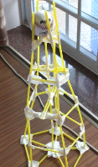  Picture from How to Build a Straw Tower by Jimmie Lanley | Structure Challenge –  Provide straws, tape, etc. and challenge your child to build the tallest free-standing structure, or one that can support the weight of a tennis ball. What shape base is the sturdiest?

Patterns & Relations Activities

- Ask your child to help plant the garden following a pattern (colours of flowers or tomato plants, stones around the garden…)

- Make a growing pattern with toothpicks and have your child keep it going.

Stats & Probability Activities

- Have your child collect data on what your guests would like to drink, or have on the BBQ…

- Discuss a current event your child is interested in. Talk about first and second hand sources of information, data reliability (fake news)…

